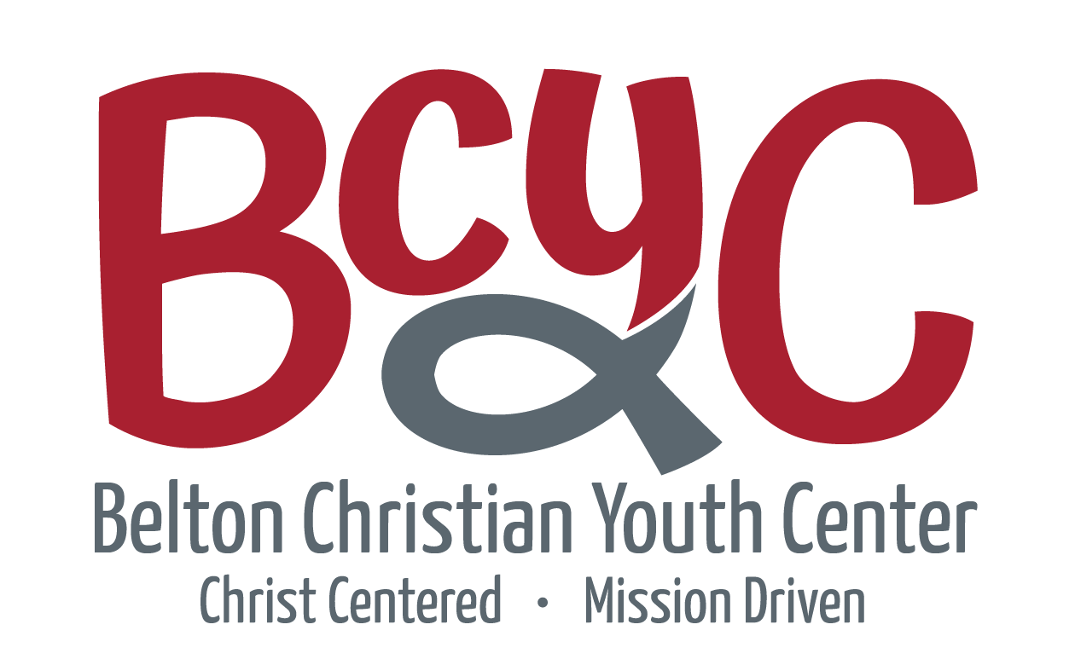

505 East Avenue C • Belton, Texas 76513 • 254-939-5759
wwww.beltonyouth.com

Belton Christian Youth Center (BCYC) is pleased to announce the opening of our Summer Camp Program Pre-Registration.

BCYC is going to be limiting in the number of children we serve this summer. Therefore the registration process will be different:
- Pre-registration Application
- Parent Interview
- Final Acceptance
- Payment of Registration and 1st Week Fee
Pre-Registration Forms need to completed and returned by May 3rd. BCYC staff will then take the applications and use the information provided to fill the 110 spaces we have available. The process will not necessarily be on a first come first serve basis but by availability per age/classroom. BCYC is striving to provide a safe and fun summer experience for every child and we feel we can better obtain that objective by using this process.

Once BCYC staff have completed reviewing the applications and filled the classrooms for each age group, we will notify everyone who applied for a spot in summer camp. We anticipate this process to be completed and notification made by May 10th. The parents of those who are going to attend this summer will be scheduled a time to come into the office to complete the remainder of the paperwork and visit with our summer camp leadership staff.

Summer pricing will be only on a weekly only basis. The cost will be $125.00 a week for the first child and $110.00 for second or additional. The registration fee this summer will be $35.00 per child. Payment must be made prior to each week beginning or your child will not be allowed to attend.

